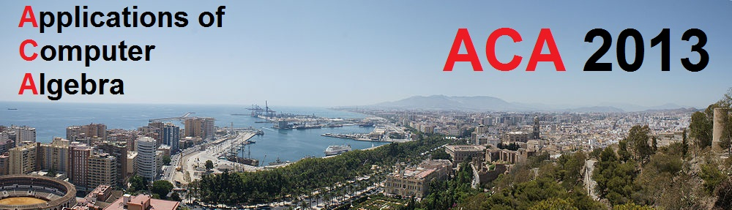

Conference Registration Form

ACA 2013, July 2nd - 6th, Málaga, Spain. Visit http://aca2013.uma.es/

Please, fill in the grey areas with the required information and send the completed form to:
aca2013@ctima.uma.es

Conference Delegate Information:

Title: |  | First Name: |  | Last (family) Name:
e-mail: |  |  |  | Country:
Institution or Company:
Department:
Phone/Fax:

Accompanying Person(s) List the names of all persons accompanying the conference delegate (if any):

Special meal requirements:

Vegetarian menus or menus for those with food allergies are available. Indicate any special needs of this sort in the following space.

Registration Fees: Payment must be done with credit card in Euro funds (€).

Registration fee for conference delegates will cover admission to all presentations, Conference materials, lunches, coffee breaks, Tuesday’s welcome reception, Wednesday and Thursday excursions (with dinners), Friday's banquet dinner and discount prices for Thyssen and Picasso's Museums.
Registration fee for accompanying persons will cover Tuesday’s welcome reception, Wednesday and Thursday excursions (with dinners), Friday's banquet dinner, an extra excursion on Friday morning and discount prices for Thyssen and Picasso's Museums.

1 | Registration fee for conference delegate  Late, after May 25th (395 Euros): | 395 | Euros
 | Registration(s) for accompanying person(s)  Late, until May 25th (320 Euros each): |  | Euros
 | Total: |  | Euros

In order to help us plan sufficient resources, we ask you to mark with an X in the right place:

Tuesday’s welcome reception |  | YES | NO
 | I plan to attend
 | My accompanying person(s) plan to attend
Wednesday’s excursion (Málaga Centre) |  | YES | NO
 | I plan to attend
 | My accompanying person(s) plan to attend
Thursday’s excursion (Alhambra, Granada) |  | YES | NO
 | I plan to attend
 | My accompanying person(s) plan to attend
Friday's banquet dinner |  | YES | NO
 | I plan to attend
 | My accompanying person(s) plan to attend

Payment:

Registration fees must be paid by credit card in Euro funds. Confirmation of registration will be sent to you, be e-mail, within 10 days after reception of payment.

The delegate’s name must appear on the payment form.

In order to pay the registration fees, please refer to the registration section on the web (http://aca2013.uma.es/) and follow the given instructions.

Comments:

